Coakley Middle School Project

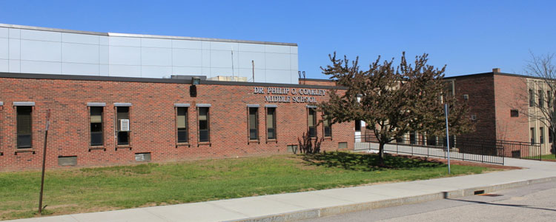

3rd COMMUNITY FORUM
Sponsored by: The Middle School Building Committee (MSBC)

Thursday; April 29, 2021 at 7:00PM

Please join us for a project update and continued discussion regarding this exciting opportunity for the Town of Norwood! All residents are invited to attend and encouraged to participate.
The project team will provide updates regarding:
- Project status including design Options
- Discussion on Enrollment: 6-8 vs. 5-8
- Next steps and important upcoming meetings.
- Question & Answer session(s).

This forum will be conducted virtually using Zoom.

You must register in advance for this webinar at:

When: Apr 29, 2021 07:00 PM Eastern Time (US and Canada)
https://zoom.us/webinar/register/WN_FB8ach3pQoWLCEFRrYhMhQ

For more info, visit the project’s website at: www.newcmsproject.org
Questions or comments can be sent to: cmsproject@norwoodma.gov

